Name the Elevation projection that matches the letter on the provided line.

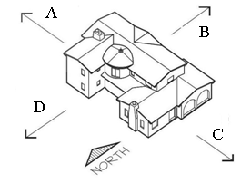

A______________________

B _____________________

C _____________________

D _____________________

Based on the diagram above, name the Elevations on the provided lines.

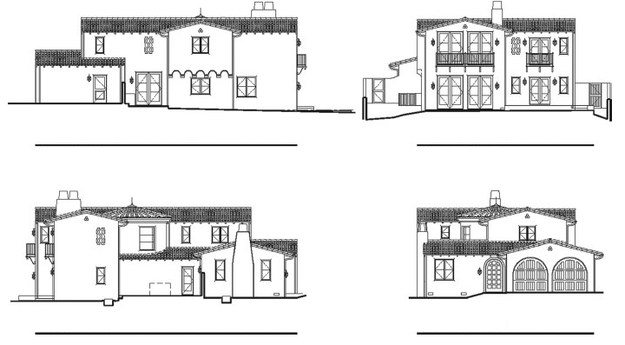

Match the architectural line with the name on the space provided.

1.___OBJECT LINE

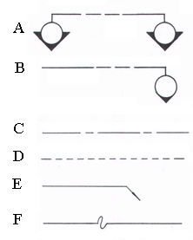

2.___BREAK LINE

3.___LEADER

4.___DIMENSION LINE

5.___EXTENSION LINE

6.___PROPERTY LINE

7.___CENTER LINE

8.___HIDDEN LINE

9.___DETAIL

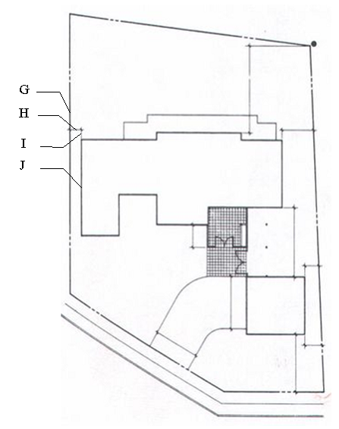

10.___MAJOR SECTION

Match the symbol with the name on the space provided.

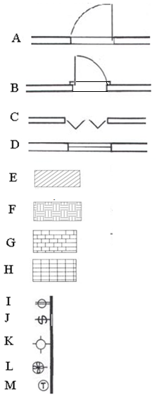

1.____FIXED WINDOW

2.____CASEMENT WINDOW

3.____EXTERIOR DOOR WITH SILL

4.____BI-FOLD DOOR

5.____EARTH

6.____BRICK

7.____WALL FIXTURE

8.____THERMOSTAT

9.____FAN

10.____OUTLET

11.____SWITCH

12.____STACKED BOND

13.____RUNNING BOND